**Theoretical and Experimental Parametric Study of Modified Stepped Solar Still**

*A.E. Kabeel a, A. Khalil a,Z.M. Omara b, M.M. Younes b*

*a Mechanical Power Engineering Department, Faculty of Engineering, Tanta University, Tanta, Egypt.*

*b Mechanical Engineering Department, Faculty of Engineering, Kafrelsheikh University, Kafrelsheikh, Egypt.*

*kabeel6@hotmail.com*

**Abstract**

In this paper, a stepped basin is used to improve the performance of solar still. An experimental as well as theoretical investigation is carried out. Two solar stills are used simultaneously and both use saline water; a conventional single sloped solar still and a modified stepped solar still. The influence of depth and width of trays on the performance of the stepped solar still is investigated. Feed water temperature to the stepped still is varied using a vacuum tube solar collector. For further augmentation of the yield a wick on the vertical sides is added to the stepped still. A good agreement between the experimental and theoretical results is observed. The results show that the productivity of the stepped solar still strongly depends on the tray depth and width. Also it is found that maximum productivity of stepped still is achieved at a tray depth 5 mm and tray width 120 mm, which is about 57.3% higher than that of the conventional still. In this case the daily efficiency and estimated cost of 1 l of distillate for stepped and conventional solar stills are approximately 53% - 0.039$ and 33.5% - 0.049 $ respectively.

**1. Introduction**

Water is considered one of the prime elements responsible for life on earth. It covers three-fourths of the surface of the earth. However, over most of earth’s water is found in oceans as salt water, contains too much of salt, cannot be used for drinking, growing crops or most industrial uses. The remaining earth’s water supply is fresh water. Globally, 200 million hours are spent each day, mostly by females, to collect water from distant, often polluted sources. In the world, 3.575 million people die each year from water related diseases [1].

Solar still is widely used in solar desalination processes. But the productivity of the solar still is very law. To enhance the productivity of the single basin solar still many research works are being carried out up till now. Glass, rubber and gravel are some of materials that used as thermal storage materials [2, 3]. A solar still was tested with a special phase changing material as energy storage media at its base [4]. The performance of a solar still with different size sponge cubes placed in the basin was studied experimentally [5]. The results showed that the increase of daily productivity from 18% to 27%. Higher energy is required to heat the entire water area of the solar still. Instead, the surface water alone can be heated with less energy and thus improving productivity. Floating perforated plate [6] and baffle suspended absorber plates [7] are also used.

Zaki et al. [8] investigated experimentally an active single slope solar still integrated with a flat plate collector and found that the maximum increase in the yield was up to 33%. A flat plate collector was integrated with a single basin solar still by Badran et al. [9] and Tiris et al. [10]. They found that the maximum increase in productivity of potable water was 52%. Velmurugan et al. [11, 12] integrated a mini solar pond with single basin solar still for enhancing the productivity of the still from salt water. The productivity was increased by 57.8%. Depth of water in the solar still inversely affects the productivity of the solar still. Maintaining minimum depth in the solar still is very difficult. For maintaining minimum depth, wicks, plastic water purifier and stepped solar still were used.

It has been reported that tilted-wick type solar stills have some advantages over the basin type, especially their attractive performance in distillation. In an experimental study on a tilted wick type solar still, Tanaka et al. [13] found an increase in distillate output of 20–50% against basin types. Tiwari et al. [14] used a multi wick solar still with electrical blower. M. Sakthivel et al. [15] conducted experiments in a modified solar still by keeping jute cloth in vertical position in the middle of the water basin and another row of jute cloth attached to the still wall. They found that the cumulative still yield increases approximately by 20% and efficiency increases by 8%. A basin type double slope solar still with mild steel plate was fabricated and tested with minimum mass of water and different wick materials like light cotton cloth, sponge sheet, coir mate and waste cotton pieces in the basin [16]. A concave wick surface was used for evaporation, whereas four sides of a pyramid shaped still were used for condensation, Kabeel [17]. A plastic water purifier was designed by Ward [18].

Velmurugan et al [19] designed and analyzed a stepped still. Also Velmurugan et al [20] used a stepped still and a settling tank to desalinate the textile effluent. A maximum increase in productivity of 98% is reported in stepped solar still when fin, sponge and pebbles are used in this basin. In addition Velmurugan et al. [21, 22] studied the augmentation of saline streams in solar stills integrated with a mini solar pond. Industrial effluent was used as feed for fin type single basin solar still and stepped solar still a maximum productivity of 100% was obtained when the fin type solar still was integrated with pebble and sponge. When a mini solar pond, stepped solar still and a single basin solar still are put in series, a maximum productivity of 80% is obtained, when fins and sponges are used in both the solar stills. When a mini solar pond, stepped solar still and wick type solar still are connected in series, It is found that maximum productivity of 78% occurred, when fins and sponges are used in the stepped solar still. Two cascade solar stills [23] were constructed with and without latent heat thermal energy storage system.

From the above review, it has been observed that the effect of varying both depth and width of trays on the performance of the stepped still is not considered. Therefore, the objective of this work is to investigate the performance of a stepped solar still by :-

1. Using trays with different depth and width.
2. Adding wick on the vertical sides.
3. Supplying preheated water into the solar still.

**2. Experimental Setup**

Two solar stills were designed and constructed to compare the performance of the solar desalination systems. Figure 1 shows a photo of the erected experimental setup. In addition, the schematic diagram of the experimental setup is shown in Fig. 2. It consists of a saline water tank, a vacuum tube solar collector, a conventional still (single basin solar still) and a stepped solar still. Basin area of the conventional still is 1 m2 (0.5 m x 2.0 m). High-side wall depth is 450 mm and the low-side wall height is 160 mm. The still is made of Galvanized steel sheets. The whole basin surfaces are coated with black paint from inside to increase the absorptivity. Also, the still is insulated from the bottom to the side walls with sawdust of 4 cm thick to reduce the heat loss from the still to ambient. The insulation layer is supported by a wooden frame. The basin is covered with a clear glass sheet 3 mm thick inclined at nearly 30o horizontally, which is the latitude of Kafrelsheikh, Egypt to maximize the amount of incident solar radiation. The whole experimental setup is kept in the south direction to receive maximum solar radiation throughout the year.

The stepped still has the same dimension and construction of conventional still, in addition the absorber plate is made of 5 steps (each of size 0.1m ×2m). Figure 3 shows a view of the steps with trays on horizontal side and wick on the vertical side of the steps. K-type thermocouples in combination with a modular PLC was used to measure the base, water, and glass temperatures of the studied stills. The saline water temperature was measured at all steps then the average value was taken. Solar radiation was measured by a calibrated solar pyranometer. A flask of 2 liter capacity was used to measure the hourly yield. Vane type digital anemometer was used to measure the wind velocity.

**3. Experimental Procedure**

Experiments were conducted at the at the Faculty of Engineering, Kafrelsheikh University, Egypt and carried out from 9 am to the sun set during July to November 2010. The solar radiation, ambient temperature, and the temperature of basin plate, saline water, glass cover and distilled water are measured every 1 hour. The accumulated productivity during the day is also measured. The depth of the saline water in the solar stills is kept constant during the experiment. All measurements were performed to evaluate the performance of the conventional still and the stepped solar still under the outdoors of Kafrelsheikh City conditions.

Effect of different saline water depths on the performance of stepped still are investigated; namely 5, 10 and 20 mm. Four groups of experiments are carried out. The first group is done with water depth kept constant at 5 mm in each still. The stepped still have trays of height 5 mm and tested with different tray width 100, 110, 120 and 130 mm. A wick on the vertical sides of the stepped still was used. Also the effect of feed water temperature in the stepped still is investigated by using evacuated tubes solar collector. In the second and third groups the water depth is kept constant in each still at 10 and 20 mm; respectively. The fourth group is a reference case, to obtain the depth which gives the higher productivity in the stepped still. So that, the conventional still with constant water depth 10 mm is tested and compared with the stepped still with water depths 5, 10 and 20 mm and trays width 120 mm.

**4. Error Analysis**

Typical measuring errors are considered and may affect the accuracy of results. The sources of these errors are thermocouples, flask, pyranometer, and vane type digital anemometer. These instruments are used for measuring temperature, distillate collection, solar intensity and wind velocity; respectively. The minimum error occurred in any instrument is equal to the ratio between its least count and minimum value of the output measured [20]. The accuracies of various measuring instruments used in the experiments are given in Table 1.

**5. Theoretical Model**

The analytical results are obtained by solving of the energy balance equations for the absorber plate, saline water and glass cover of the solar still. The saline water temperature, basin plate temperature and glass cover temperature can be evaluated at every instant.

Energy balance for the basin plate [22],

|  |  |
| --- | --- |
|  | (1) |

Energy balance for the saline water [22, 24],

|  |  |
| --- | --- |
|  | (2) |

Energy balance for the glass cover [22],

|  |  |
| --- | --- |
|  | (3) |

The hourly yield is given by the following equation,

|  |  |
| --- | --- |
|  | (4) |

The convective heat transfer between basin and water [19, 20],

|  |  |
| --- | --- |
|  | (5) |

The convective heat transfer co-efficient between basin and water, *hc,b-w* is taken as 135 W/m2 K, [19, 20].

The heat losses by convection through the basin base and sides to the ground and surrounding, given as [25],

|  |  |
| --- | --- |
|  | (6) |

Where *Ub* = *Ki*/*Li* , and *Ki*and *Li* are thermal conductivity and the thickness of the insulation; respectively [2]. The thickness of the insulation in the conventional still is smaller than that with the stepped still due to the still geometry, then for the stepped still the heat loss coefficient from basin and sides is smaller than that for conventional still.

The convective heat transfer between water and glass is given by [19, 20],

|  |  |
| --- | --- |
|  | (7) |

where the convective heat transfer coefficient between water and glass is given by [26],

|  |  |
| --- | --- |
|  | (8) |

The radiation heat transfer from the basin to glass cover is predicted from [24],

|  |  |
| --- | --- |
|  | (9) |

where



|  |  |
| --- | --- |
|  | (10) |

The evaporative heat transfer between water and glass is given by [19, 20],

|  |  |
| --- | --- |
|  | (11) |

The evaporative heat transfer coefficient between water and glass is given by [19, 20],

|  |  |
| --- | --- |
|  | (12) |

It is also assumed that, the makeup water is at atmospheric temperature and takes heat from basin. The heat taken by the replaced water is estimated from [24],

|  |  |
| --- | --- |
|  | (13) |

The radiative heat transfer between glass and sky is given by [19, 20],

|  |  |
| --- | --- |
|  | (14) |

The radiative heat transfer co-efficient between glass and sky is given by [19, 20],

|  |  |
| --- | --- |
|  | (15) |

The sky temperature is taken from [26],

|  |  |
| --- | --- |
|  | (16) |

The convective heat transfer between glass and sky, Qc,g-sky is given by [26],

|  |  |
| --- | --- |
|  | (17) |

where *hc,g-sky*is taken from [26],

|  |  |
| --- | --- |
|  | (18) |

The daily efficiency, *ηd*, is obtained by the summation of the hourly condensate production *m*, multiplied by the latent heat *hfg*, hence the result is divided by the daily average solar radiation *I(t)* over the whole area *A* of the device [27]:

|  |  |
| --- | --- |
|  | (19) |

**6. Model Validation**

The model is validated by comparing theoretical results obtained in the present work with the corresponding results obtained from the present experimental work. During the current simulation, experimentally determined operational and metrological parameters are used. Fig. 4 shows theoretical and experimental comparison of hourly variation of fresh water productivity for conventional solar still and stepped solar still. It was found that there is a good agreement between the theoretical results and the experimental data. The deviations between experimental and theoretical results for conventional still are ranging from 5% to 8%. But for stepped still the deviations are ranging from 7% to 13%.

**7. Results and Discussion**

The stepped solar still is modified using trays with different depth and width. In addition, wick on the vertical sides was used and the feed water was preheated by a solar collector. Results and discussions for the behavior and performance of the solar desalination system for stiller area of 1 m2 are presented.

**7.1 Effect of solar radiation on the performance of the solar still**

The variation of solar radiation, atmospheric temperature, base temperature, basin water temperature and glass temperature of stills are shown in Fig. 5. It is observed that the temperatures at all points increase as the time increase till a maximum value at noon and start to decrease after that. This is due to the increase of solar radiation intensity in the morning and its decrease in the afternoon. Also from Fig. 5, it can be noticed that the glass temperature and basin water temperature of stepped solar still are higher than that of conventional still by about 0-2 oC and 0-10 oC; respectively at *W*=100 mm. While at *W*=120 mm the glass temperature and basin water temperature of stepped solar still are higher than that of conventional still by about 0-4 oC and 0-3 oC; respectively, because of the condensation rate and the amount of water in the stepped still is higher than that of conventional still.

**7.2 Water Productivity**

A comparison between the hourly variation of fresh water productivity per unit area for stepped and conventional solar stills were performed and illustrated in Fig. 4. Results indicate that the fresh water productivity reaches its maximum value between 12 pm to 2 pm for the present solar desalination systems. This is because the temperature of water in the still during morning hours is low and needs more time to warm up. In addition, it can be seen that the maximum productivity occurs at time of maximum temperature of saline water. It is clear from Fig. 4 that the rate of increase of productivity during the morning hours was higher than the rate of decrease in productivity during evening hours. The same trend was noticed for saline water temperature as shown in Fig. 5.

Also, It can be observed from Fig. 4 that fresh water productivity for stepped still is greater than that of conventional type. This may be referred to two reasons: (1) a smaller air volume trapped inside the still chamber than in the conventional still and therefore heating up the trapped air will be much faster, and (2) the step-wise basin provides higher heat and mass transfer surface area than the flat basin [28]. In addition, it can be observed from Fig. 4 that when *W*=100 mm the productivity of the stepped still is approximately the same with the conventional still starting from 6:00 pm because of the amount of water in the stills was the same. While at W=120 mm the amount of saline water and the thermal energy stored in the stepped still is higher than that of the conventional still, so the productivity of the stepped still is greater than that of conventional still.

Also, measurements of daily accumulated distillate are recorded (from 9:00 am to sunset). It can be noticed that the distillate reaches approximately 3470 ml/m2day for conventional still and 4525 ml/m2day for stepped still at *Hs* = 5 mm and *W* = 100 mm; respectively, as shown in Fig. 6-a. The increase in distillate production for stepped still is 30.4% higher than that of conventional still but for stepped still at *Hs* = 5 mm and *W* = 120 mm the distillate reaches 5630 ml/m2day and 3580 ml/m2day for conventional still. As shown in Fig. 6-b, the increase in distillate production for stepped still is 57.3% higher than that for conventional still. Comparison of the daily productivity for both conventional still and stepped still at different tray width is tabulated in Table 2. Also, the magnitude of the daily productivity rise is tabulated in Table 2.

**7.3 Performance of stepped solar still with different tray width**

The effect of increasing tray width on daily productivity at different depths of saline water is shown in Fig. 7. It can be observed that increasing the tray width improves daily productivity; because the exposure area of the saline water increases. Figure 7 shows that the difference of daily productivity increases by increasing the tray width with maximum value at *W* = 120 mm and then decreases as the tray width increase because of the shadow appears on the following step and due to the increased quantity of saline water. The same behavior was observed with all water depths and different feed water temperatures.

**7.4 Performance of stepped solar still with different water depth**

Depth of saline water inversely affects productivity of solar still [22]. It was observed from the experimental results thatincreasing water depth in the stepped still decreases the productivity, but this decrease is lower than that for conventional still. To determine the water depth required for the stepped still to give the higher productivity a reference case was taken for comparison, the stepped still with different water depths (5, 10 and 20 mm) and *W* = 120 mm was tested with the conventional still of water depth *HB* = 10 mm. The results showed that the depth of 5 mm and tray width 120 mm gives the higher productivity as shown in Fig. 8.

**7.5 Effect of using wick on the vertical sides**

Using wick may have some advantages. It increases the evaporating surface area of the brine. The still can be oriented to intercept the maximum solar radiation and it provides the still with a low thermal capacity and consequently faster response to incident solar radiation (compared with basin type stills) and higher brine temperatures are achieved, which, in turn, yield higher evaporation rates. A wick on the vertical sides of the stepped still was used and the results show an increase in the productivity by 3-5% than that without wick on the vertical sides as shown in Table 2.

**7.6 Effect of preheating the feed water**

A vacuum tube solar collector was used to preheat the feed water of the stepped still. The results show that increasing the feed water temperature increases the productivity of the stepped still, as shown in Fig. 9. Also, It was reported that the distillate reaches approximately 3650 ml/m2day for conventional still and 6080 ml/m2day for stepped still at *Hs* = 5 mm and *W* = 120 mm, The increase in distillate production for stepped still is 66.6% higher than that of conventional still at *Tfw*= 86 oC.

7.7 Efficiency of the stills

The hourly efficiency of the two systems is presented in Fig. 10. The results showed that the efficiency for the stepped still is higher than for the conventional still, as shown in Fig. 10-a, and the daily efficiency of stepped and conventional still was 53% and 33.5%; respectively, for a brine depth of 5 mm and trays width of 120 mm. When the solar collector was used to preheat the feed water, the stepped still efficiency was lower than that of the conventional still as shown in Fig. 10-b, and the daily efficiency of stepped and conventional still was 28.5% and 34%; respectively, when the brine depth 5 mm and trays width 120 mm at *Tfw*= 86 oC.

The daily efficiency for the stepped solar still at different tray depth and width without solar collector is shown in Fig. 11. It can be noticed from the figure that by increasing tray depth the daily efficiency for the stepped solar still decreases while increasing tray width increases the daily efficiency till *W* = 120 mm then begins to decrease. The maximum efficiency is 53% at *Hs* = 5 mm and *W* = 120 mm.

**8. Cost Evaluation**

The total fixed cost of conventional still is about F =103 $. To obtain the average value of the cost of distillate output, it is important to assume that V is the variable cost and C is the total cost, where, C = F +‏ V. Assume variable cost V equals 0.3 F per year, as reported in [29], and the expected still life time is 10 years, then C = 103 + 0.3 × 103 × 10 = 412 $ where the minimum average daily productivity can be estimated from the analysis of different experimental data, and it is taken as 2.5 l/day. To determine the annual cost for one liter assuming that the still operates 340 days in the year, where the sun rise along the year in Egypt. The total productivity during the still life time 2.5x10x340=8500 liter. Then the cost of one liter from conventional still=412/ 8500= 0.049 $.

The total fixed cost of stepped solar still is about F = 132$ without solar collector. Assume the expected still lifetime is 10 years. It is also assumed that *V* = 0.3*F* per year, then C = 132 + 0.3 × 132 × 10 = 530 $, where the minimum average daily productivity can be estimated 4.0 l/day based on water depth 5 mm and tray width 120 mm. Assume still operate 340 days in the year. The total productivity during the still life time 4x10x340=13600 l. Therefore, the cost of one liter from stepped still= 530/13600=0.039 $.

**9. Conclusions**

From the presented experimental and theoretical results of stepped and conventional still the following conclusions can be drawn:

1. The productivity of the stepped still decreases by increasing the water depth.
2. The higher performance of stepped still is achieved at water depth 5 mm and tray width 120 mm (57.3 % higher than the productivity of the conventional still).
3. The augmentation of the daily productivity of the stepped still by using wick on the vertical sides from 3% to 5%.
4. Preheating the feed water of the stepped still has a slight effect on enhancing the productivity, but the efficiency of the system decreases approximately to the half.
5. The daily efficiency and the estimated cost per liter of distillate for stepped and conventional solar stills are approximately 53% - 0.039$ and 33.5% - 0.049 $ respectively, at water depth 5 mm and tray width 120 mm.

**Nomenclatures**

*A* area, m2

*C* specific heat, J/kg K

*HB* water depth for conventional still, mm

*Hs* water depth for stepped still (the tray height), mm

*h* heat transfer coefficient, W/m2 K

*hfg* enthalpy of evaporation at *Tw*, J/kg

*I*(*t*) solar radiation on inclined surface, W/m2

*m* mass, kg

*P* partial pressure, N/m2

*T* temperature, oC

*U* heat loss coefficient from basin and sides to ambient, W/m2 K

*W* the tray width, mm

V wind velocity, m/s

*Greeks*

*ε* emissivity

*α* absorptivity

ρ density, kg/m3

*ηd* the daily efficiency of the still

*Subscripts*

*a* ambient

*b* basin

*c*  convective

*e*  evaporative

*fw* feed water

*g* glass

*r* radiative

*w* water

**References**

1. Sampathkumar, K., T.V. Arjunan, P. Pitchandi and P. Senthilkumar, *Active solar distillation — A detailed review*, Renewable and Sustainable Energy Reviews 14 (2010) 1503–1526.
2. Abdel-Rehima, Z.S. and A. Lasheen, *Improving the performance of solar desalination systems*, Renew. Ener., 30 (2005) 1955–1971.
3. Nafey, A.S., M. Abdelkader, A. Abdelmotalip and A.A. Mabrouk, *Solar still productivity enhancement*, Energy Conversion and Management, 42 (2001) 1401–1408.
4. Naim, M.M. and M.A. Abd El Kawi, *Nonconventional solar stills Part 2. Non-conventional solar stills with charcoal particles as absorber medium*, Desalination, 153 (2002) 71–80.
5. Bassam, A.K and R. Himzeh., *Experimental study of a solar still with sponge cubes in basin*, Energy Conversion and Management, 44 (2003) 1411–8.
6. Nafey, A.S., M. Abdelkader, A. Abdelmotalip and A.A. Mabrouk, *Enhancement of solar still productivity using floating perforated black plate*, Energy Conversion and Management 43 (2002) 937–946.
7. El-Sebaii, A.A., S. Aboul-Enein and E. El-Bialy, *Single basin solar still with baffle suspended absorber*, Energy Conversion and Management 41 (2000) 661–675.
8. Zaki, G.M., A. Al-Turki and M. AI-Fatani, *Experimental investigation on concentrator assisted solar stills*, Solar Energy 11 (1992) 193–199.
9. Badran Ali A, A. Ahmad, E.S. Imad and O. Mohammad, *A solar still augmented with a flat plate collector*, Desalination 172 (2005) 227–234.
10. Tiris, C., M. Tiris, Y. Erdalli and Y.Sohmen, *Experimental studies on a solar still coupled with a flat-plate collector and a single basin still*, Energy Conversion and Management 39 (1998) 853–6.
11. Velmurugan, V., K. Mugundhan and K. Srithar, *Experimental studies on solar stills integrated with a mini solar pond*, 3rd BSME-ASME international conference on thermal engineering, Dhaka, Bangladesh, 2006.
12. Velmurugan, V. and K. Srithar, *Solar stills integrated with a mini solar pond — analytical simulation and experimental validation*, Desalination 216 (2007) 232–241.
13. Tanaka, K., A. Yamashita and K. Watanabe, *Experimental and analytical study of the tilted wick type solar still*, Solar worm forum, vol. 2. Oxford: Pergamon Press; 1982.
14. Tiwari, G.N. and H.N. Singh, T. Rajesh, *Present status of solar distillation*, Solar Energy 75 (2003) 367–373.
15. Sakthivel, M., S. Shanmugasundaram and T. Alwarsamy, *An experimental study on a regenerative solar still with energy storage medium - Jute cloth*, Desalination 264 (2010) 24–31.
16. Murugavel, K.K. and K. Srithar, *Performance study on basin type double slope solar still with different wick materials and minimum mass of water*, Renewable Energy 36 (2011) 612-620.
17. Kabeel, A. E., *Performance of solar still with a concave wick evaporation surface*, Energy 34 (2009) 1504–1509.
18. Ward, J., *A plastic solar water purifier with high output*, Solar Energy 75 (2003) 433–437.
19. Velmurugan, V., S.S. Kumaran, N. Prabhu and K. Srithar, *Productivity enhancement of stepped solar still – performance analysis*. Thermal Science 12 (2008) 153–163.
20. Velmurugan, V., K.J.N. Kumar, T.N. Haq and K. Srithar, *Performance analysis in stepped solar still for effluent desalination*, Energy 34 (2009) 1179–1186.
21. Velmurugan, V., J. Mandlin, B. Stalin and K. Zrithar, *Augmentation of saline streams in solar stills integrating with a mini solar pond*, Desalination 249 (2009) 143–149.
22. Velmurugan, V., S. Pandiarajan, P. Guruparan, H. Subramanian, D. Prabaharan and K. Srithar, *Integrated performance of stepped and single basin solar stills with mini solar pond*, Desalination 249 (2009) 902–909.
23. Tabrizi, F.F., M. Dashtban and H. Moghaddam, *Experimental investigation of a weir-type cascade solar still with built-in latent heat thermal energy storage system*, Desalination 260 (2010) 248–253.
24. Murugavel, K.K., S. Sivakumar, J. Riaz Ahamed, Kn.K.S.K. Chockalingam and K. Srithar, *Single basin double slope solar still with minimum basin depth and energy storing materials*, Applied Energy 87 (2010) 514–523
25. Rahul D. and G.N. Tiwari, *Characteristic equation of a passive solar still*, Desalination 245 (2009) 246–265.
26. Yousef, Z.H. and K.A. Mousa, *Modeling and performance analysis of a regenerative solar desalination unit*, Applied Thermal Engineering 24 (2004) 1061–1072.
27. Velmurugan, V., C.K. Deenadayalan, H. Vinod and K. Srithar, *Desalination of effluent using fin type solar still*, Energy 33 (2008) 1719–1727.
28. Abdallah, S., O. Badran, M. Mazen and A. Khader, *Performance evaluation of a modified design of a single slope solar still*, Desalination 219 (2008) 222–230.
29. Kabeel, AE., *Performance of solar still with a concave wick evaporation surface*, Energy 34 (2009) 1504–1509.

**Table 1**  Accuracies and error for various measuring instruments:

|  |  |  |  |
| --- | --- | --- | --- |
| Instrument | Accuracy | Range | % Error |
| Pyranometer | ± 1W/m2 | 0-5000 W/m2 | 2.5 |
| Calibrated flask | ± 5 ml | 0-2000 ml | 5 |
| Vane anemometer | ± 0.1 m/s | 0-30 m/s | 5 |

**Table 2** Accumulated productivity for some days

|  |  |  |  |  |  |  |  |
| --- | --- | --- | --- | --- | --- | --- | --- |
| Date | Conditions | | | | Daily Productivity, ml/m2day | | Daily Productivity rise % |
| H (mm) | W (mm) | Tfw (oC) | Wick | Conventional still | Stepped still |
| 20-7-2010 | 5 | 100 | 35 | without | 3470 | 4525 | 30.4 |
| 16-8-2010 | 5 | 110 | 33 | without | 3880 | 5650 | 45.6 |
| 28-8-2010 | 5 | 120 | 33 | without | 3580 | 5630 | 57.3 |
| 23-9-2010 | 5 | 130 | 31 | without | 2810 | 4260 | 51.6 |
| 28-7-2010 | 5 | 100 | 32 | with | 3485 | 4685 | 34.4 |
| 05-8-2010 | 5 | 100 | 80 | with | 3940 | 6020 | 52.8 |
| 18-8-2010 | 5 | 110 | 87 | without | 3710 | 6060 | 63.3 |
| 21-8-2010 | 5 | 110 | 34 | with | 3460 | 5190 | 50.0 |
| 22-8-2010 | 5 | 110 | 85 | with | 3330 | 5530 | 66.0 |
| 29-8-2010 | 5 | 120 | 86 | without | 3650 | 6080 | 66.6 |

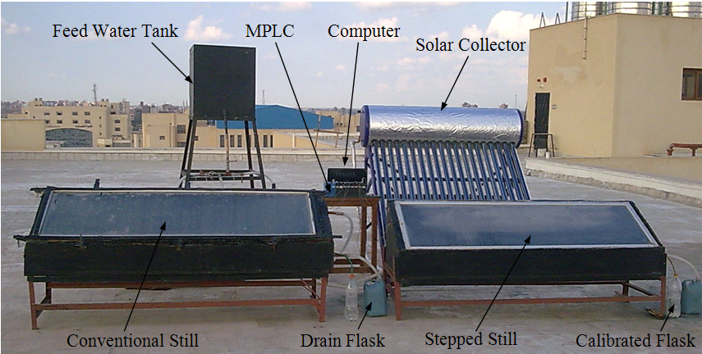

Fig. 1. A photo of the experimental setup.

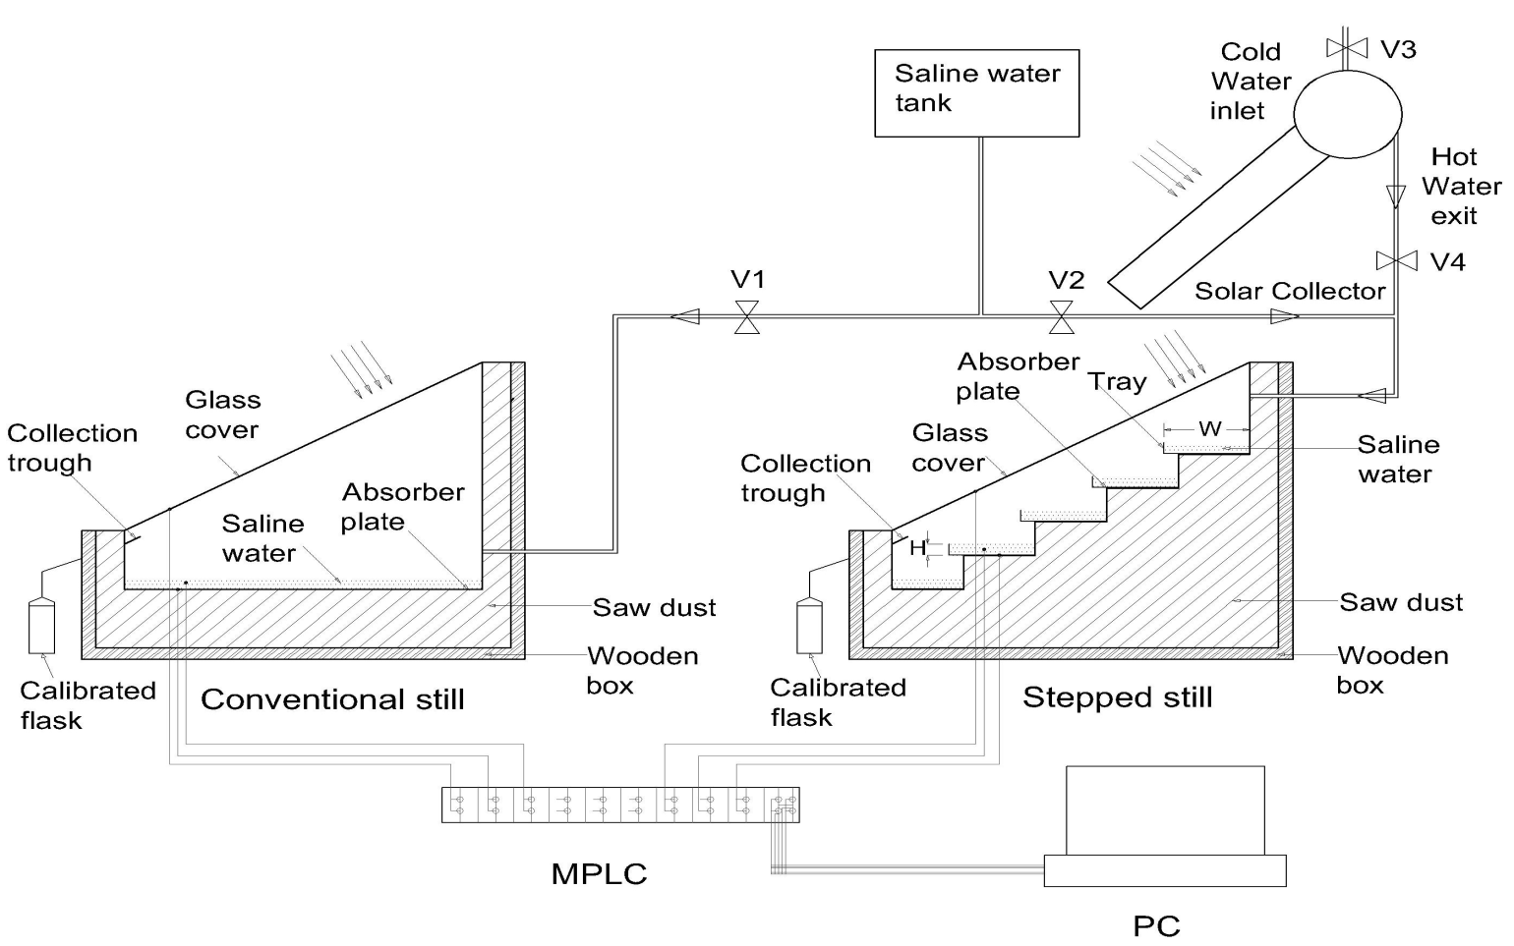

Fig. 2. Schematic diagram of the experimental set up.

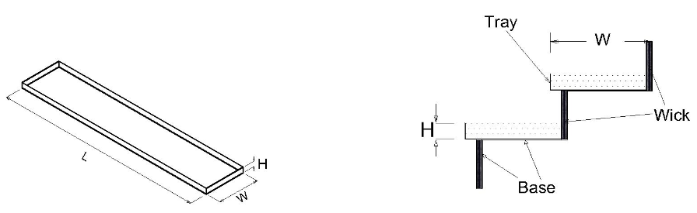

|  |  |
| --- | --- |
| 3-a. View of tray | 3-b. Tray on horizontal side and wick on  vertical side of the step. |

Fig. 3. View of tray and wick on the steps of the stepped still.



(4-a) H = 5 mm and W = 100 mm (4-b) H = 5 mm and W = 120 mm

Fig. 4. The variation of fresh water productivity for the stepped and the conventional still.



(5-a) H = 5 mm and W = 100 mm (5-b) H = 5 mm and W = 120 mm

Fig. 5. The hourly temperature variation and solar radiation for the stepped and conventional still.



(6-a) H = 5 mm and W = 100 mm (6-b) H = 5 mm and W = 120 mm

Fig. 6. The accumulative variation of fresh water for the stepped and the conventional still.



Fig. 7. Effect of increasing tray width on the difference of the productivity.



Fig. 8. Difference of productivity with different water depth and the same tray width and *HB*=10 mm.



Fig. 9. Difference of productivity with different feed water temperature Tfw at W=120 mm and different water depth H.



(10-a) H = 5 mm and W = 120 mm (10-b) H = 5 mm and W = 120 mm

Fig. 10. Hourly efficiency variation for conventional and stepped still at different feed water temperature.



Fig. 11. Daily efficiency variation for stepped still at different tray width and depth.