Name | PROF. DR. HOSSAM ELDIN FAWZY ABD ELFATAH
Photo | 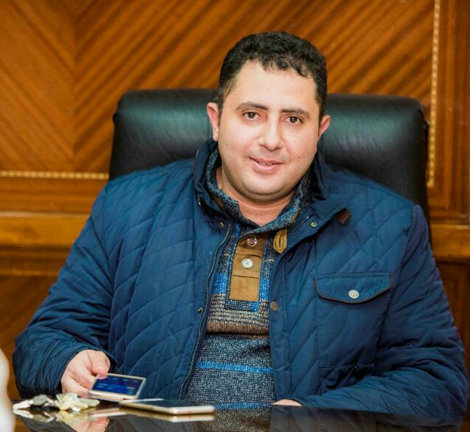
Degree | ASSOCIATE PROFESSOR OF CIVIL ENGINEERING ENGINEERING (SURVEYING)
Department | CIVIL ENGINEERING DEPARTMENT
General Specialization | CIVIL ENGINEERING DEPARTMENT
Specialization | SURVEYING DEPARTMENT
Home page
Google Scholar | https://scholar.google.com.eg/citations?user=9dsfiAYAAAAJ&hl=ar
E-Mail | hossameldinfawzy@yahoo.com
Mobile | 01069593537
Qualifications | PhD. in " Civil Engineering " (2010)
 | MSc. in " Civil Engineering " (2007)
 | Bachelor of Engineering in "Civil Engineering" (2001)
Research interests | Surveying Engineering
Recent Publications | - A Hala M. Ebaid, Hossam El-Din Fawzy & Ahmed F. El Shouny “ Automatic Coastline Extraction Using Satellite Images” IOSR Journal of Mechanical and Civil Engineering (IOSR-JMCE) e-ISSN: 2278-1684,p-ISSN: 2320-334X, Volume 12, Issue 4 Ver. III (Jul. - Aug. 2015), PP 81-86.  http://www.iosrjournals.org/iosr-jmce/pages/12%284%29Version-3.html  - Hossam El-Din Fawzy “The efficient of using the close range photogrammetry technique instead of a precise terrestrial surveying technique for deformation monitoring in unstable structure buildings” International Journal of Civil Engineering & Technology (IJCIET), Volume 6, Issue 10, October 2015, pp. 176-186, ISSN Print: 0976 – 6308, ISSN Online: 0976 – 6316.  http://www.iaeme.com/ijciet/issues.asp?VType=6&IType=10&JType=IJCIET&PageNumber=2
Conferences | -
Position | HEAD OF CIVIL ENGINEERING DEPARTMENT KAFRELSHEIKH UNIVERSITY
Devices of Department | --
Head of Department | Prof. Dr. HOSSAM ELDIN FAWZY
Contact us | 01069593537
Subjects of Bachelor | CIVIL ENGINEERING
Subjects of post Graduates | ----

