Name | Ismail Sobhy Yousef
Photo | 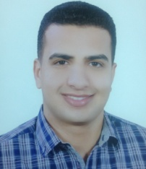
Degree | Associate Professor of Engineering Mathematics
Department | Physics and Engineering Mathematics Department
General Specialization | Physics and Engineering Mathematics
Specialization | Engineering Mathematics
Home page | http://www.kfs.edu.eg/staff_site/index.aspx?staff=1188&topic=15261
Google Scholar | https://scholar.google.com.eg/citations?user=8nnu9akAAAAJ&hl=en
E-Mail | esmail_yossif@eng.kfs.edu.eg
Mobile | 01094186946
Qualifications | Bachelor of Engineering in "Electrical Power and Machines" (2014)
Research interests | Engineering Mathematics, Numerical Analysis, Fractional Differential Equation, Ordinary Differential Equations, Partial Differential Equations, Fuzzy Differential Equations
Recent Publications
Conferences
Position | --
Devices of Department | --
Head of Department | Prof. Dr. Arafa A. Nasef
Contact us | 01094186946
Subjects of Bachelor | Engineering Mathematics 1, Engineering Mathematics 2, Engineering Mathematics 3, Engineering Mathematics 4
Subjects of post Graduates | Stability Analysis of Electrical Systems

