Name | Dr. Ahmed Saeed Abd Elrazek
Photo | 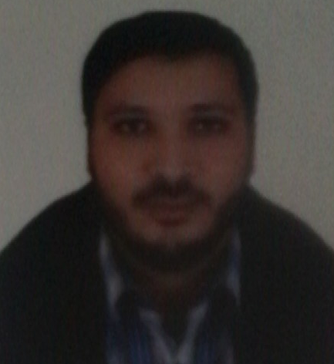
Degree | Associate Professor of Engineering Physics
Department | Physics and Engineering Mathematics Department
General Specialization | Physics and Engineering Mathematics
Specialization | Engineering Physics
Home page | -
Google Scholar | https://scholar.google.com.eg/citations?user=Q9wY17wAAAAJ&hl=ar
E-Mail | ahmed.bayoumi@eng.kfs.edu.eg
Mobile | 01003796199
Qualifications | PhD. in "Engineering Physics" (2016)
 | MSc. in "Engineering Physics " (2013)
 | Bachelor of Engineering in "Electronics and communication" (2005)
Research interests | Nanotechnology, Spintronics and renewable energy
Recent Publications | Ahmed S. Abdelrazek, Mohamed M. El-banna, Adel H. Phillips, " Photo-Spin Coherent Manipulation of Piezotronic Nanodevice", Micro & Nano Letters 11 (12), 876-880
Conferences | -
Position | --
Devices of Department | --
Head of Department | Prof. Dr. Arafa A. Nasef
Contact us | 01095587002
Subjects of Bachelor | Engineering Physics 1, Engineering Physics 2
Subjects of post Graduates | ----

