Name | Dr. Demyana Adel Abdelmasieh Saleeb
Photo | 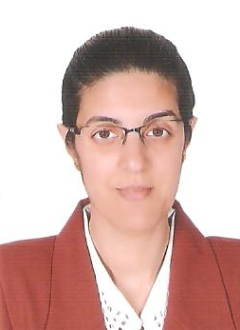
Degree | Lecturer
Department | Physics and Engineering Mathematics Department
General Specialization | Engineering Physics
Specialization | Communication, Electromagnetic
Home page | http://www.kfs.edu.eg/staff_site/display.aspx?topic=5594&staff=473
Google Scholar | https://scholar.google.com.eg/citations?user=79aV7ToAAAAJ&hl=en&citsig=AMstHGS1hhU4HRV8vOnkKxiWd-v5ECs3mA
E-Mail | demyanasaleeb@eng.kfs.edu.eg
Mobile | 01229601669
Qualifications | PhD. in "Communication Engineering" (2015)
 | MSc. in "Communication Engineering" (2010)
 | Bachelor of Engineering in "Communication" (2005)
Research interests | Engineering Physics, Electromagnetic, Microwaves, Antennas.
Recent Publications | Band Notching UWB Planar Monopole Antenna Using EBG, Samar A Saad, Ahmed S. Elkorany, Demyana A. Saleeb
Conferences | Second International conference ( Tenth Conference of sustainable Environmental Development ) " during 16-20 March 2019, Sharm Elsheikh.
Position | --
Devices of Department | --
Head of Department | Prof. Dr. Arafa A. Nasef
Contact us
Subjects of Bachelor | Engineering Physics 1, Engineering Physics 2
Subjects of post Graduates | ----

