Name | Dr. Hany Khaled Koheil
Photo | 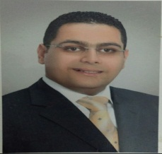
Degree | Associate Professor of Chemical Engineering
Department | Physics and Engineering Mathematics Department
General Specialization | Chemical Engineering
Specialization | Chemical Engineering
Home page | www.kfs.edu.eg/staff_site/display_cv.aspx?staffid=854&staff=39
Google Scholar | https://scholar.google.com.eg/citations?user=Nlrlyh8AAAAJ&hl=en
E-Mail | hanykoheil@eng.kfs.edu.eg
Mobile | 01090075000
Qualifications | PhD. in " Chemical Engineering " (2012)
 | MSc. in " Chemical Engineering " (2006)
 | Bachelor of Chemical Engineering (2000)
Research interests | Chemical Engineering , Waste Water Treatment
Recent Publications | ----
Conferences | ----
Position | ----
Devices of Department | ----
Head of Department | Prof. Dr. Arafa A. Nasef
Contact us | 01090075000
Subjects of Bachelor | Introduction in Chemical Engineering , Techincal Report , Engineering and Environment .
Subjects of post Graduates | ----

