Name | Dr. Manal Elsayed Ali Moustafa Ali
Photo | 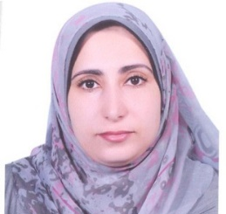
Degree | Associate Professor of Engineering Mathematics
Department | Physics and Engineering Mathematics Department
General Specialization | Physics and Engineering Mathematics
Specialization | Engineering Mathematics
Home page | www.kfs.edu.eg/manal.html
Google Scholar | https://scholar.google.com.eg/citations?user=krwMMsAAAAAJ&hl=en
E-Mail | manal.ali@eng.kfs.edu.eg
Mobile | 01095587002
Qualifications | PhD. in "Engineering Mathematics" (2011)
 | MSc. in "Engineering Mathematics" (2008)
 | Bachelor of Engineering in "Electronic Computers and Automatic Control" (2002)
Research interests | Engineering Mathematics, General Topology, Rough Sets, Fuzzy Sets, Granular Computing, Decision Making, Information Systems.
Recent Publications | A. Abdelzaher, M. E. Ali, and Tamer Ibrahim, “ Evaluating the Attributes Affecting Rationalization of  Pure Water Consumption in Egypt by Using Rough Set Techniques”, the ²nd international conference on mathematics, statistics & information technology (icmsit 2018), Tanta University.
Conferences | The ²nd international conference on mathematics, statistics & information technology (icmsit 2018), Tanta University.
Position | --
Devices of Department | --
Head of Department | Prof. Dr. Arafa A. Nasef
Contact us | 01095587002
Subjects of Bachelor | Engineering Mathematics 1, Engineering Mathematics 2, Engineering Mathematics 3, Engineering Mathematics 4
Subjects of post Graduates | ----

