Name | Ghada Mostafa Abdelhamed Hamisa
Photo | 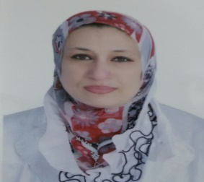
Degree | Lecturer of Computer Engineering and Systems
Department | Electrical Engineering Department
General Specialization | Computer Engineering and Control Systems
Specialization | Computer & Software Engineering
Home page | ---
Google Scholar | https://scholar.google.com.eg/citations?user=OHP-GFsAAAAJ&hl=en&oi=ao
E-Mail | ghada.hamesa@eng.kfs.edu.eg
Mobile | +201068406348
Qualifications | PhD. in " Computer Engineering and Automatic Control " (2012)
 | MSc. in "Computer Engineering and Automatic Control " (2006)
 | Bachelor of Engineering in "Electronic Computers and Automatic Control" (1998)
Research interests | Computer Science, Computer Security, Data encryption. Software Engineering, Database Management Systems, Data Quality and Warehousing, and Data governance.
Recent Publications | ---
Conferences | ---
Position | ---
Devices of Department | ---
Head of Department | Prof. Dr. Abdel-Fattah Attia
Contact us | +201068406348
Subjects of Bachelor | Database Management Systems, Advanced database, Computer Security, Software Engineering, Computer Technology, Multimedia, and Technical writing.
Subjects of post Graduates

