Name | Dr. Tamer Medhat Mohammed Ibrahim
Photo | 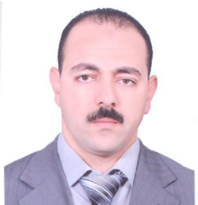
Degree | Associate Professor of Computer and Automatic Control
Department | Electrical Engineering Department
General Specialization | Computer and Automatic Control
Specialization | Granular Computing
Home page | www.kfs.edu.eg/drtamer.html
Google Scholar | https://scholar.google.com.eg/citations?user=l7Dv-q0AAAAJ&hl=en
E-Mail | tmedhatm@eng.kfs.edu.eg
Mobile | 01001317693
Qualifications | PhD. in "Engineering Mathematics" (2007)
 | MSc. in "Engineering Mathematics" (2004)
 | Bachelor of Engineering in "Electronic Computers and Automatic Control" (1998)
Research interests | Computer Science, General Topology, Rough Sets, Fuzzy Sets, Granular Computing, Engineering Mathematics, Decision Making, Information Systems, Neural Networks, Augmented Reality.
Recent Publications | A. Abdelzaher, M. E. Ali, and Tamer Ibrahim, “ Evaluating the Attributes Affecting Rationalization of Pure Water Consumption in Egypt by Using Rough Set Techniques”, the 2nd international conference on mathematics, statistics & information technology (icmsit 2018), Tanta University.
Conferences | The 2nd international conference on mathematics, statistics & information technology (icmsit 2018), Tanta University.
Position | - Egyptian Universities Network Manager: From 15/12/2018 up to now.  - Chief Information Officer of Kafrelsheikh University: from 1/9/2010 up to 14/12/2018.  - Kafrelsheikh University Representative at National Committee for ICTP (Information & Communication Technology Project): From 27/12/2007 up to now.  - Director of MIS (Management Information Systems) Project at Kafrelsheikh University: from 27-12-2007 to 30-9-2010.
Devices of Department | --
Head of Department | Prof. Dr. Abdel-Fattah Attia
Contact us | 01001317693
Subjects of Bachelor | Computer Technology, Data Structure and Algorithms, Compilers, Selected topics in Computer Sciences, Project.
Subjects of post Graduates | ----

